|  |
| --- |
| Vanier College – Computer Science Department |
| Onyx Hotel |
| User Manual |

Ali Raza & David Sousa Jorge

420‐331‐VA : Application Development

Teacher: Syed Naseem Afzal

Tuesday, December 06, 2022

Table of Contents

Introduction: 2

Setting up the code 2

Gui Application: 5

Login Page: 6

Main Page: 8

Task Page: 9

Reservation Page: 11

Miscellaneous Page: 14

Internationalization: 16

# Introduction:

Our group project is a hotel management system with a database called “Onyx Hotel”. The project will be a GUI-based application that aims to help a small newly made hotel that wants to keep track of its reservation and see the different rooms that are available for a guest as well as the different kinds of room that they have at the moment of the reservation (could be a single, double, triple, or quad room). Furthermore, the employees who are logged into the system may also see the different tasks assigned to them depending on their roles and responsibilities which can help facilitate their job. The main objective of our application is to make the hotel’s reservation task simple and efficient, while also helping the employees keep track of their duties.

# Setting up the code

Please use the following user and password in order to log into the application (User: Admin & Password: 1234)

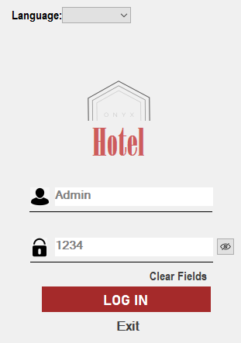

For the connection to the Database, there will be an error, would have to fix it by doing the following:

Click the following Database:



Then proceed to the highlighted area:

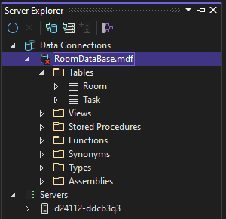

In properties please copy the following String Path you see:

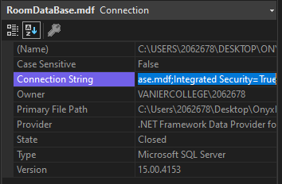

Then please go inside room form and tasks form code and replace this line with the copied String Path:





Do the same for the Rooms form and paste the new String connection path in every place in order to fix database connection errors.

# Gui Application:

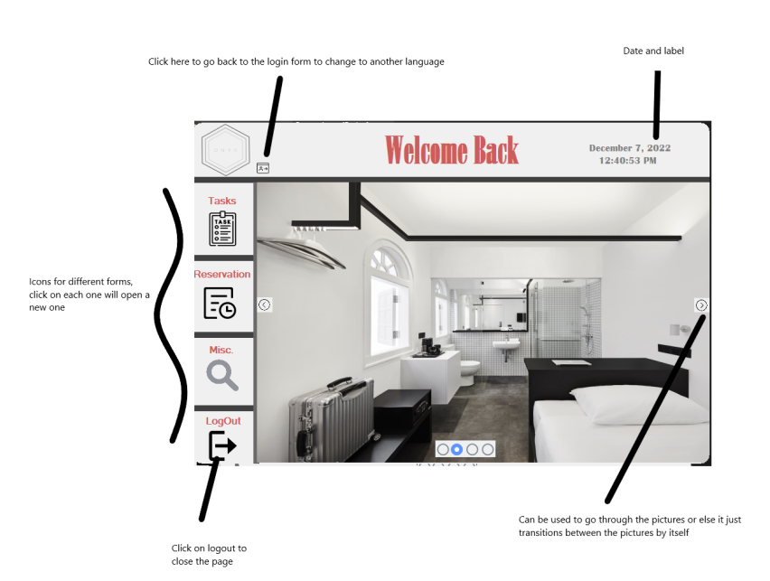

# Login Page:

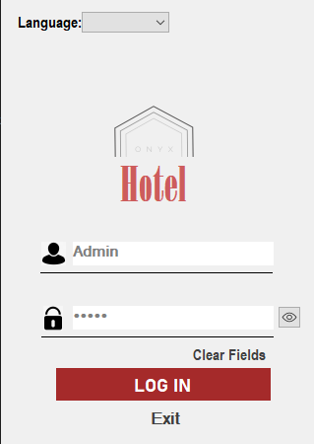

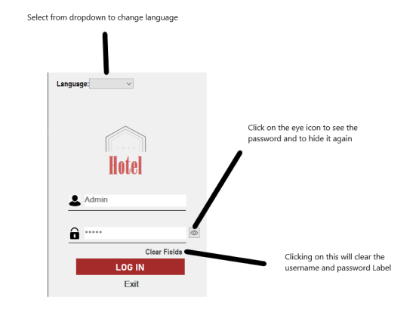

When entering the wrong password, the following message is displayed:

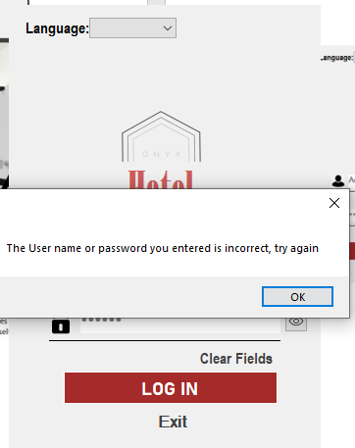

# Main Page:

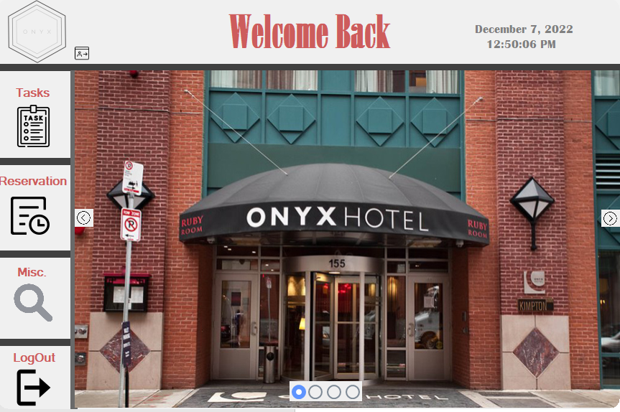

Transitions through the pictures or can use the arrows to go through them manually

# Task Page:

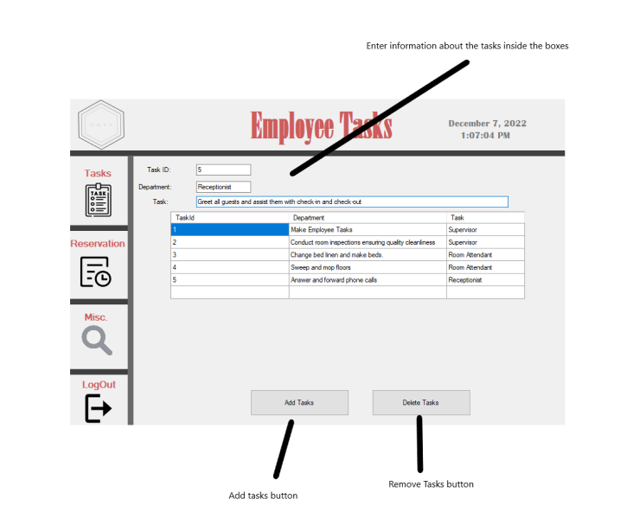

Entering a new task:

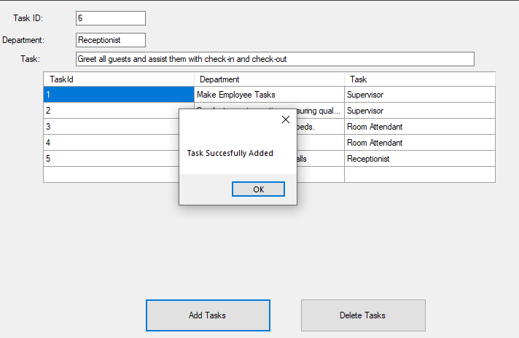

Deleting a task:

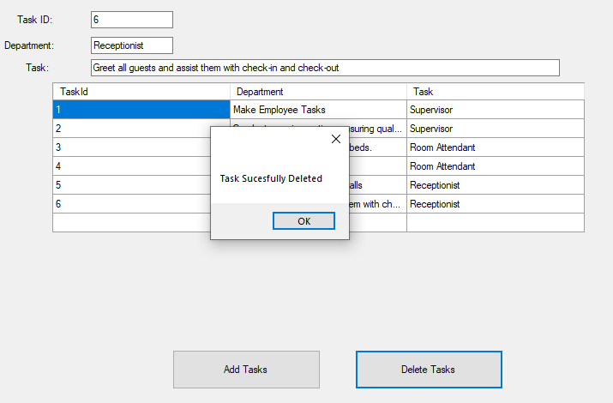

# Reservation Page:

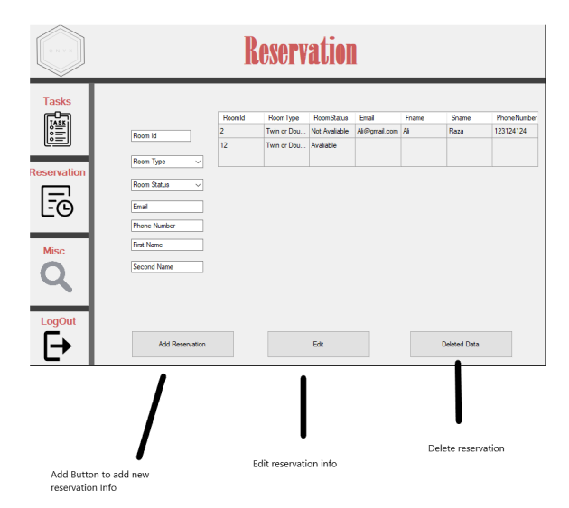

Add new reservation:

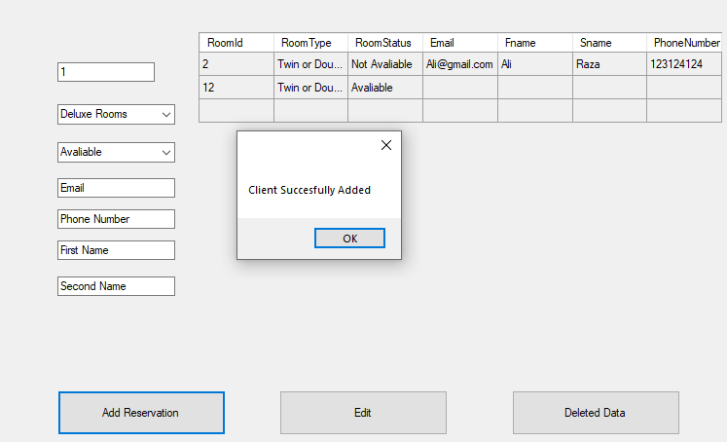

Edit Reservation:

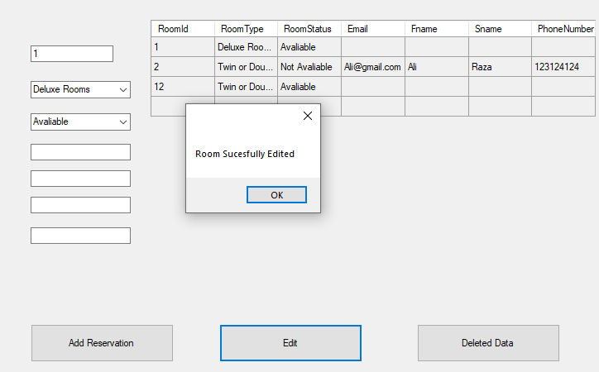

Deleting Reservation:

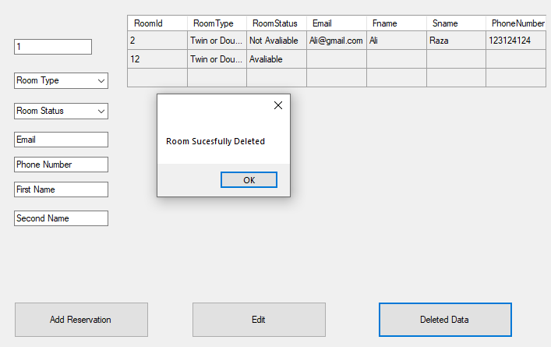

# Miscellaneous Page:

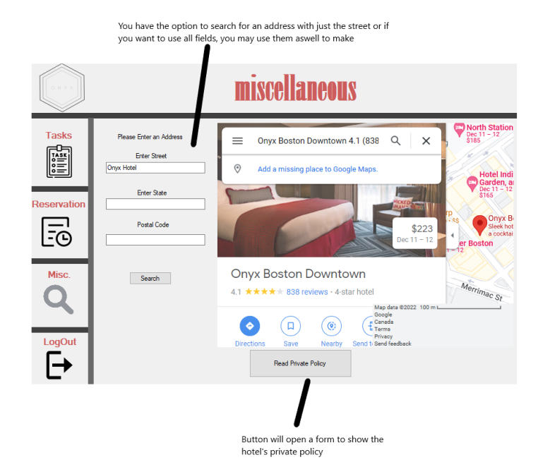

Private Policy form

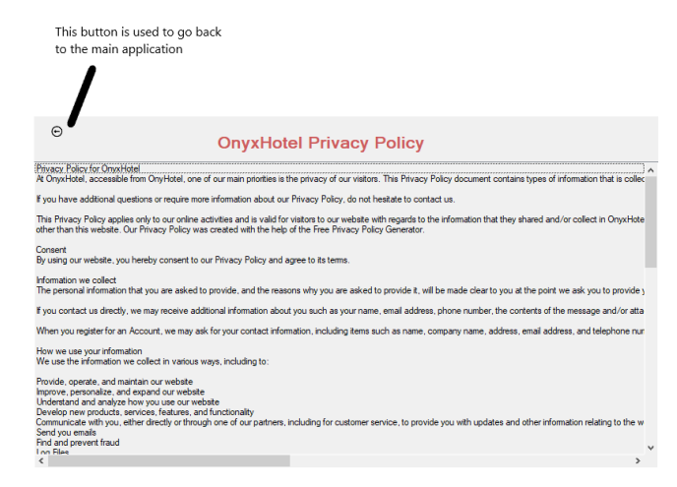

# Internationalization:

